Sustainable Smart city Assistant using granite LLM

A sustainable smart city assistant is an intelligent system that leverages technology to improve the quality of life and resource management while promoting environmental sustainability. It encompasses various applications like AI-powered energy management, personalized citizen services, and optimization of city operations. Essentially, it's about using technology to make cities more efficient, livable, and environmentally friendly

IDEATION PHASE
Brainstorm & Idea Prioritization:
Brainstorming provides a free and open environment that encourages everyone within a team to participate in the creative thinking process that leads to problem solving. Prioritizing volume over value, out-of-the-box ideas are welcome and built upon, and all participants are encouraged to collaborate, helping each other develop a rich amount of creative solutions.
Idea prioritization is the process of evaluating and ranking ideas based on their potential value and feasibility to focus resources on the most impactful initiatives. It's crucial for ensuring that innovation efforts are efficient, aligned with goals, and lead to optimal outcomes.
REQUIREMENT ANALYSIS
Customer journey map:
Creating a customer journey map for a sustainable smart city assistant involves visualizing how citizens interact with the assistant across various stages—while embedding sustainability at every touchpoint. Here's a simplified outline to get you started
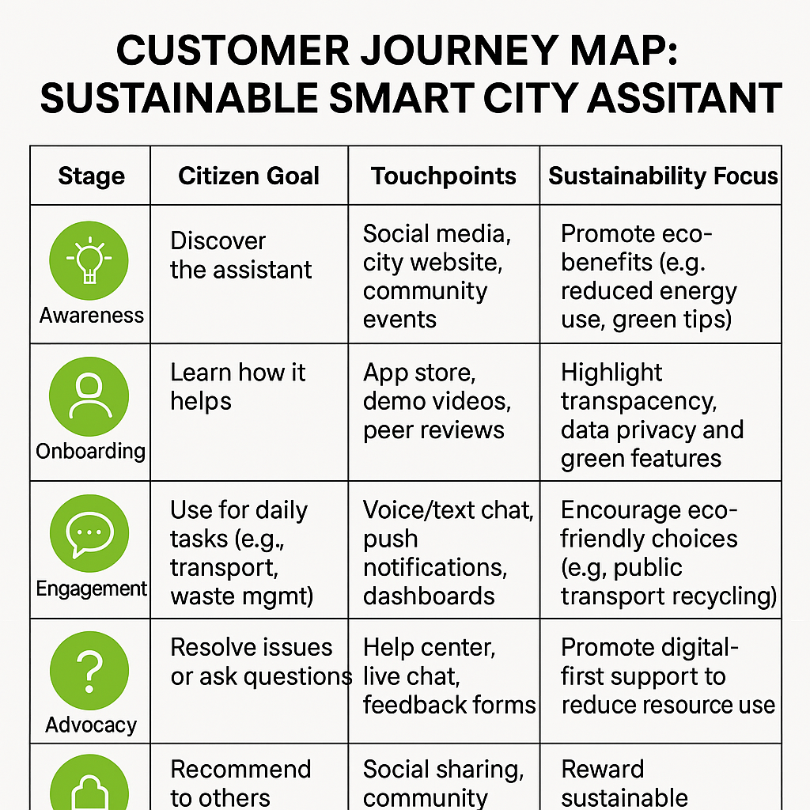
Data Flow Diagram:
A Sustainable Smart City Assistant is a digital tool designed to help citizens and city officials make eco-conscious decisions using real-time data and intelligent systems. It integrates technologies like AI, IoT, and cloud computing to manage urban services—such as transport, energy, waste, and water—more efficiently and sustainably.

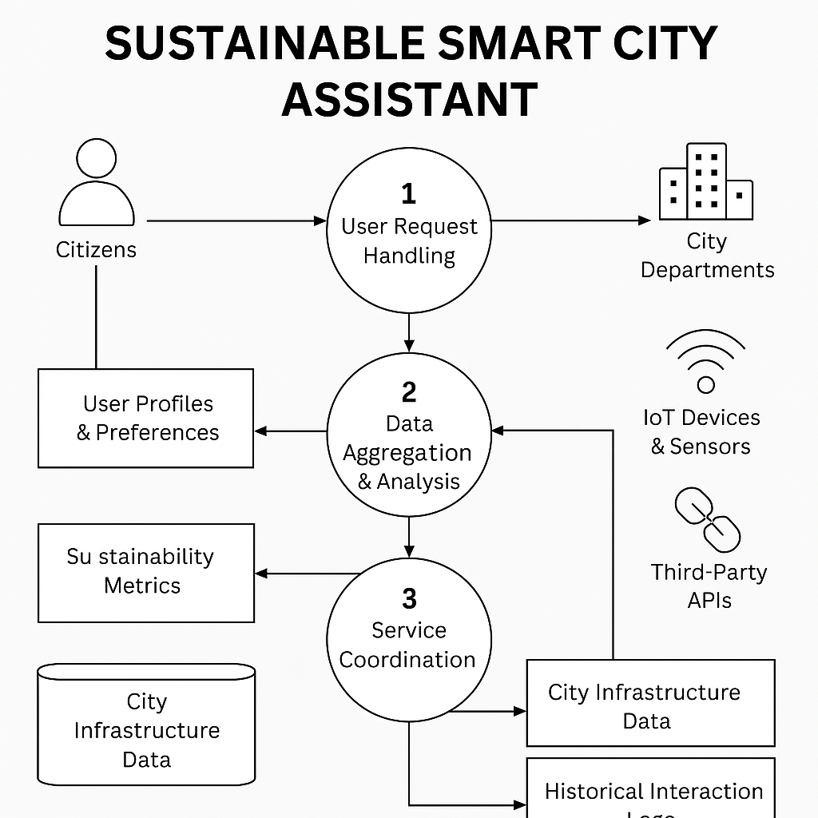
Technology stack:
To build a Sustainable Smart City Assistant, you need a robust and scalable technology stack that integrates real-time data, intelligent decision-making, and citizen engagement
Layer | Technologies / Tools | Purpose
User Interface (UI) | Streamlit, React, Flutter | Interactive dashboards, mobile/web apps for citizen interaction
Application Layer | FastAPI, Node.js, Django | Business logic, API routing, service orchestration
AI & Analytics | IBM Watsonx, Scikit-learn, TensorFlow, PyTorch | Natural language processing, forecasting, anomaly detection
Data Layer | PostgreSQL, MongoDB, Pinecone (vector DB), FPDF/Markdown | Structured/unstructured data storage, document generation
IoT & Sensors | Arduino, Raspberry Pi, LoRaWAN, Zigbee, MQTT | Real-time data collection from city infrastructure
Cloud & Edge | AWS, Azure, Google Cloud, EdgeX Foundry | Scalable computing, edge processing for low-latency responses
Security & Privacy | OAuth 2.0, SSL/TLS, Blockchain, GDPR-compliant frameworks | Data protection, secure transactions, citizen trust
Integration Layer | RESTful APIs, WebSockets, GraphQL | Seamless communication between services and third-party systems
Monitoring & DevOps | Prometheus, Grafana, Docker, Kubernetes, Jenkins | System health, containerization, CI/CD pipelines
This stack enables the assistant to deliver real-time insights, support sustainable urban services, and ensure secure, inclusive citizen engagement.
Technical Architecture:
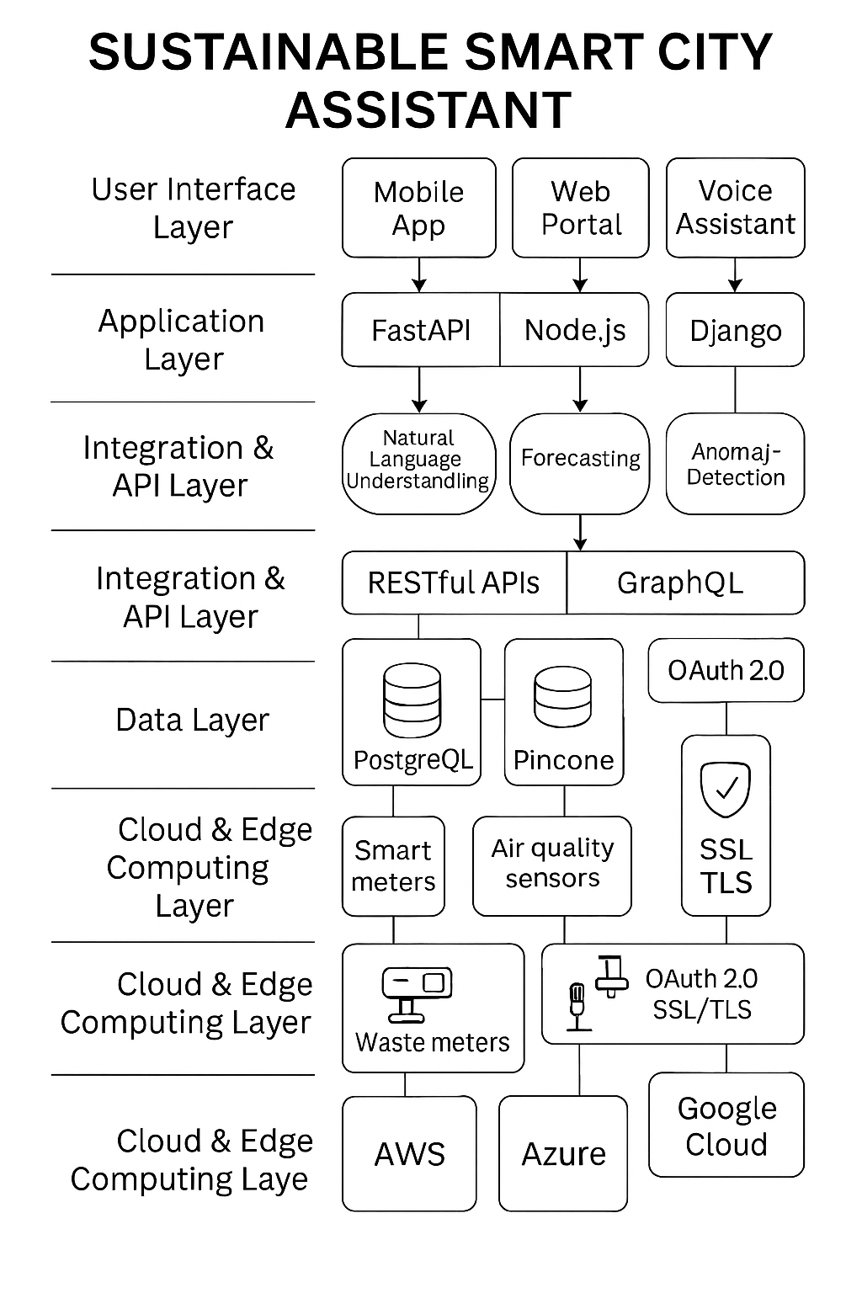
DESIGN PROJECT
Problem solution Fit:
Citizens lack real-time access to eco-friendly transport and energy data
→ The assistant provides live updates on green transit, energy usage, and sustainability tips.
- City departments face fragmented data and delayed responses
→ The assistant integrates IoT data and automates alerts and service coordination.
- Residents are unaware of local sustainability programs or incentives
→ The assistant sends personalized notifications about green initiatives and rewards.
- Reporting urban issues (like waste overflow) is difficult and time-consuming
→ The assistant enables voice/text-based issue reporting with automated routing to departments.
- There’s no feedback loop for continuous improvement
→ The assistant collects user feedback and usage data to refine and evolve services.
Proposed solution:
- AI-Powered Citizen Assistant
  - A multilingual chatbot and voice assistant that helps citizens access services, report issues, and receive sustainability tips in real time.
- IoT-Driven Urban Monitoring
  - Integration with smart sensors for air quality, traffic, energy, and waste to provide real-time data for decision-making.
- Personalized Sustainability Dashboard
  - A mobile/web interface showing individual and community-level metrics like energy use, water consumption, and carbon savings.
- Green Mobility Integration
  - Real-time updates on public transport, EV charging stations, and bike-sharing options to promote low-emission travel.
- Smart Waste & Water Management
  - Automated alerts for waste overflow, leak detection, and optimized collection routes using predictive analytics.
- Community Engagement & Rewards
  - Gamified features that reward eco-friendly behavior (e.g., recycling, using public transport) with points or local incentives.
- Open Data & Transparency
  - Public dashboards and APIs to foster trust, innovation, and third-party solution development.
- Security & Privacy by Design
  - End-to-end encryption, GDPR-compliant data handling, and user-controlled data sharing preference
Solution Architecture:
- User Interaction Layer
  - Interfaces: Mobile app, web portal, voice assistant
  - Purpose: Enables citizens to access services, report issues, and receive sustainability tips
- Application & Service Layer
  - Technologies: FastAPI, Node.js, Django
  - Functions: Handles business logic, workflows, and service orchestration
- AI & Intelligence Layer
  - Tools: IBM Watsonx, TensorFlow, Scikit-learn
  - Capabilities: Natural language understanding, forecasting, anomaly detection, recommendations
- Data Management Layer
  - Databases: PostgreSQL, MongoDB, Pinecone
  - Stores: User profiles, sensor data, sustainability metrics, feedback logs
- IoT & Sensor Integration Layer
  - Devices: Smart meters, air quality sensors, waste bin sensors
  - Protocols: MQTT, LoRaWAN, Zigbee
  - Role: Real-time data collection from city infrastructure
- Integration & API Layer
  - Interfaces: RESTful APIs, GraphQL, WebSockets
  - Purpose: Connects internal modules and third-party services (e.g., weather, maps)
- Cloud & Edge Computing Layer
  - Platforms: AWS, Azure, Google Cloud, EdgeX Foundry
  - Role: Scalable processing, low-latency responses, secure storage
- Security & Governance Layer
  - Technologies: OAuth 2.0, SSL/TLS, Blockchain (optional)
  - Policies: GDPR compliance, access control, audit logs
FUNCTIONAL AND PERFORMANCE TESTING
Functional Testing
- Verify user interactions (voice/text) return accurate and relevant responses.
- Test integration with external APIs (e.g., weather, transport, energy).
- Validate real-time data processing from IoT sensors (e.g., air quality, waste bins).
- Ensure workflows like issue reporting and service scheduling function end-to-end.
- Confirm authentication, data encryption, and privacy compliance (e.g., GDPR).
Performance Testing
- Conduct load testing to simulate high user traffic and ensure stability.
- Perform stress testing to evaluate system behavior under extreme conditions.
- Measure latency for real-time services like traffic or energy updates.
- Test scalability with increasing IoT data and user base.
- Monitor system resource usage (CPU, memory, bandwidth) under various loads.
RESULTS
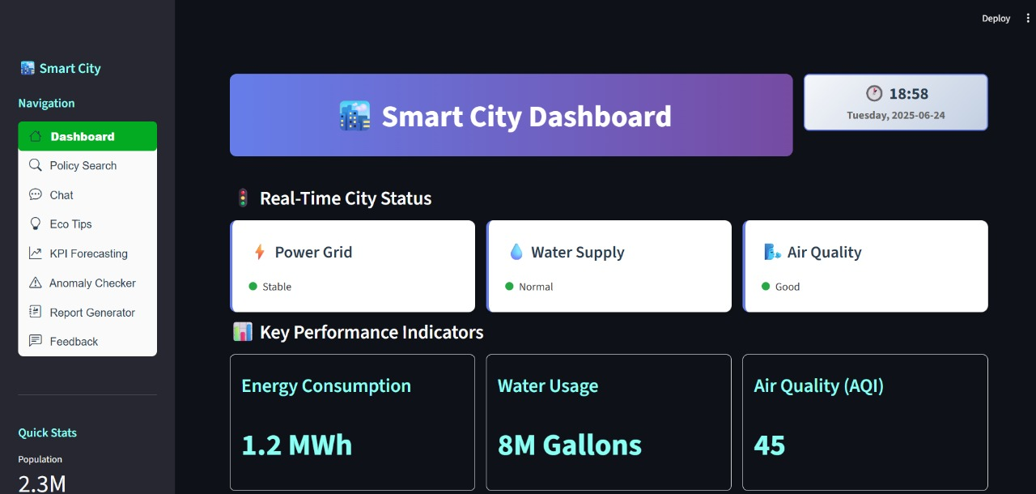
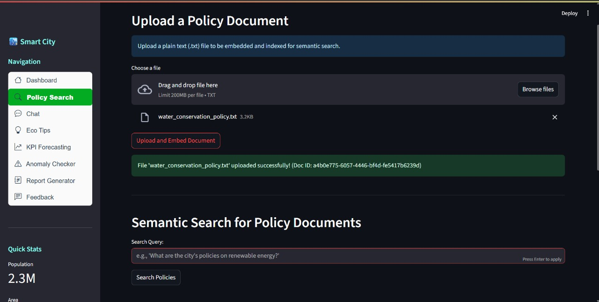
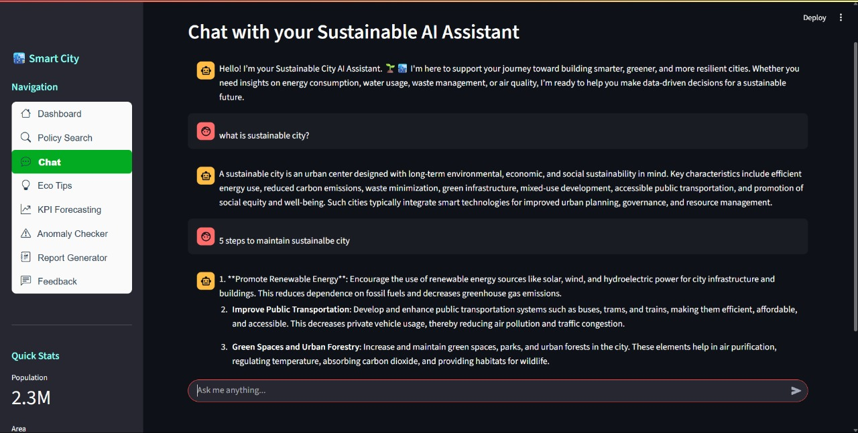
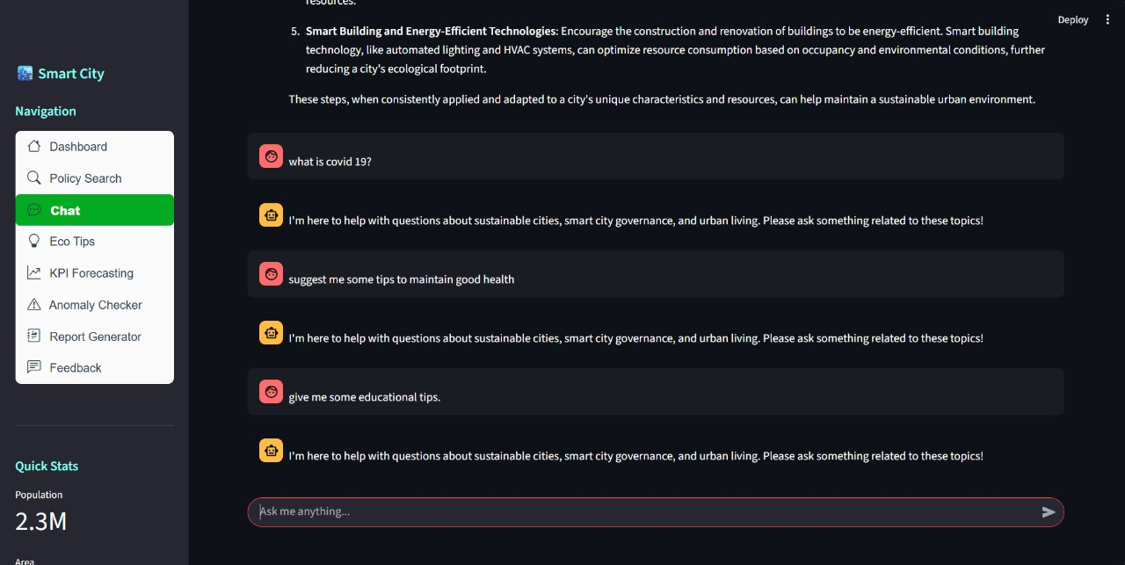
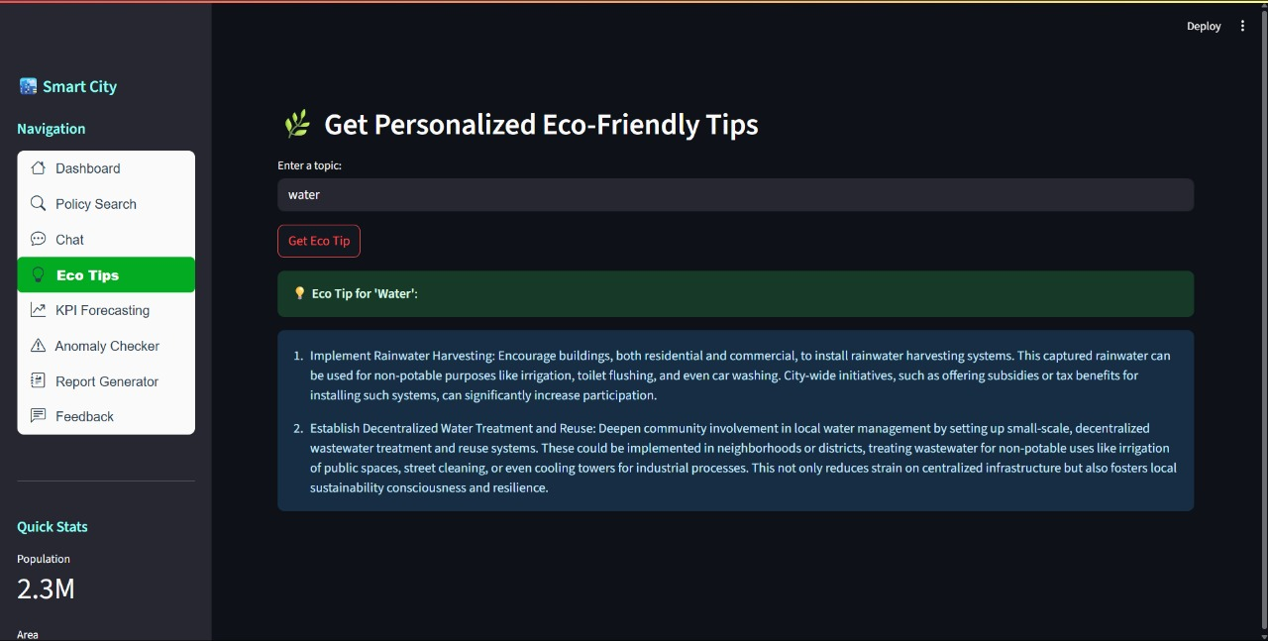
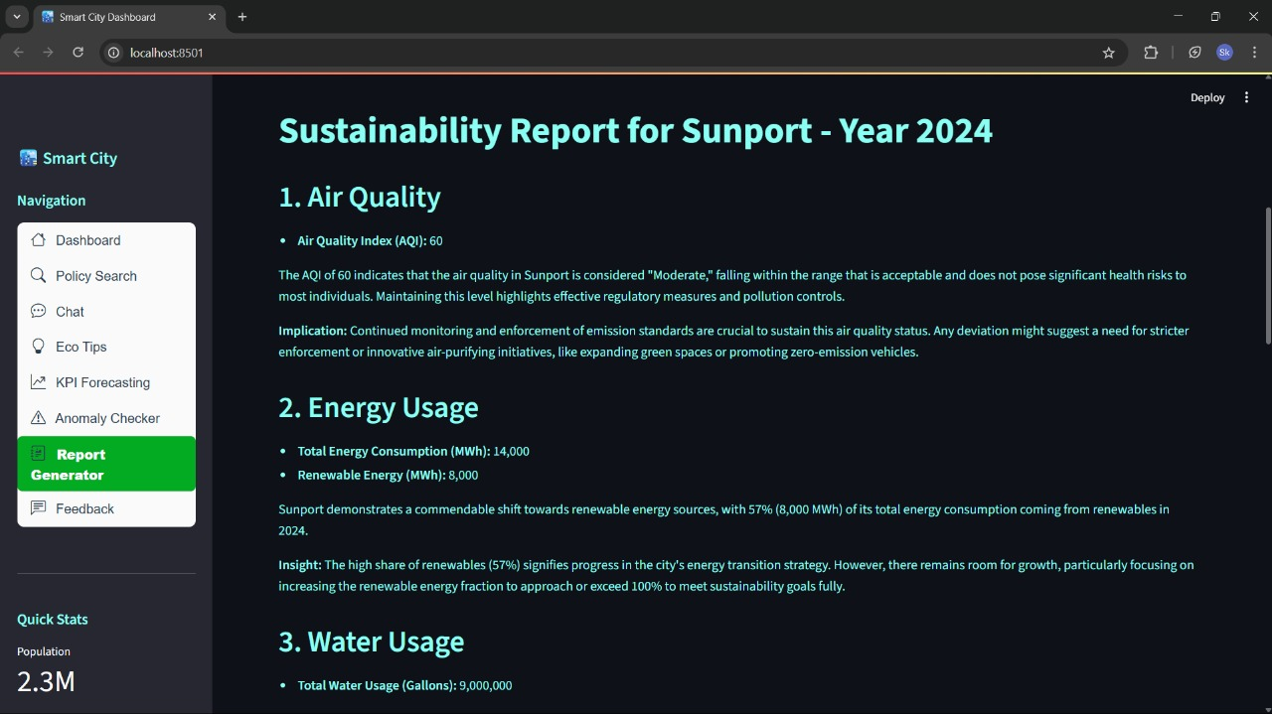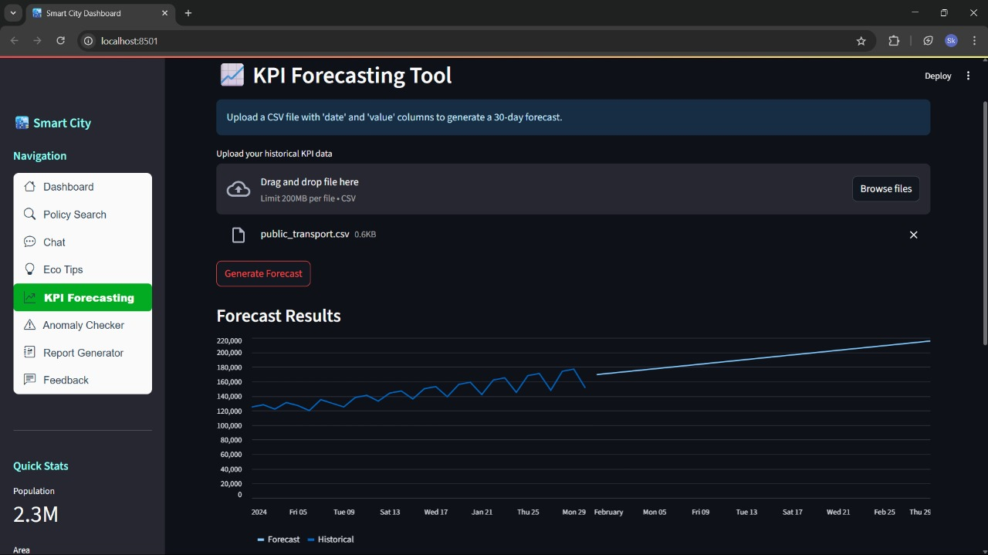
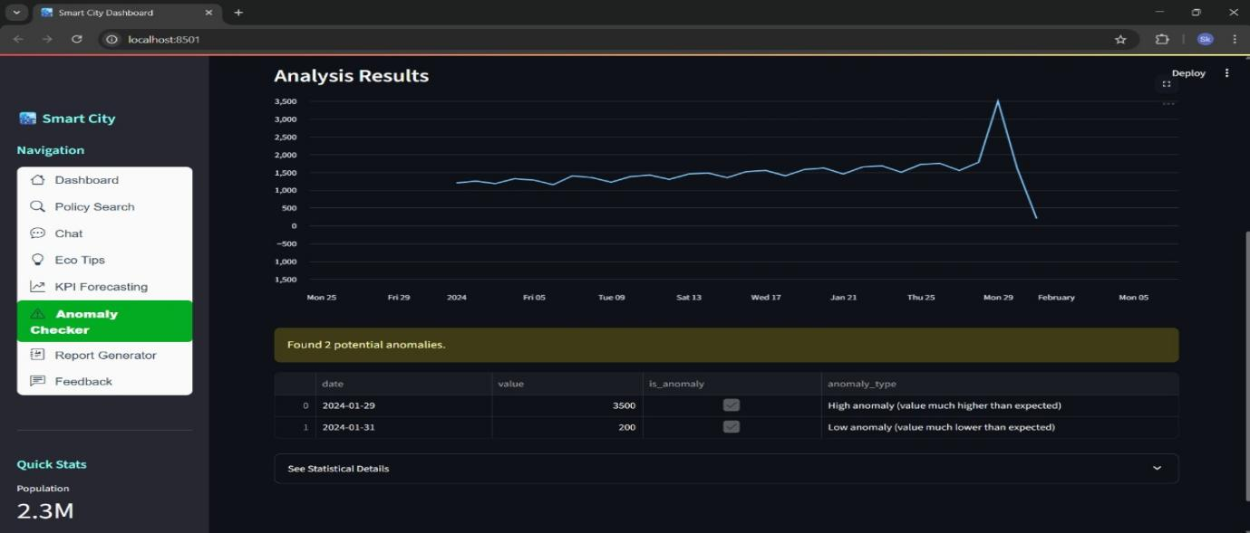
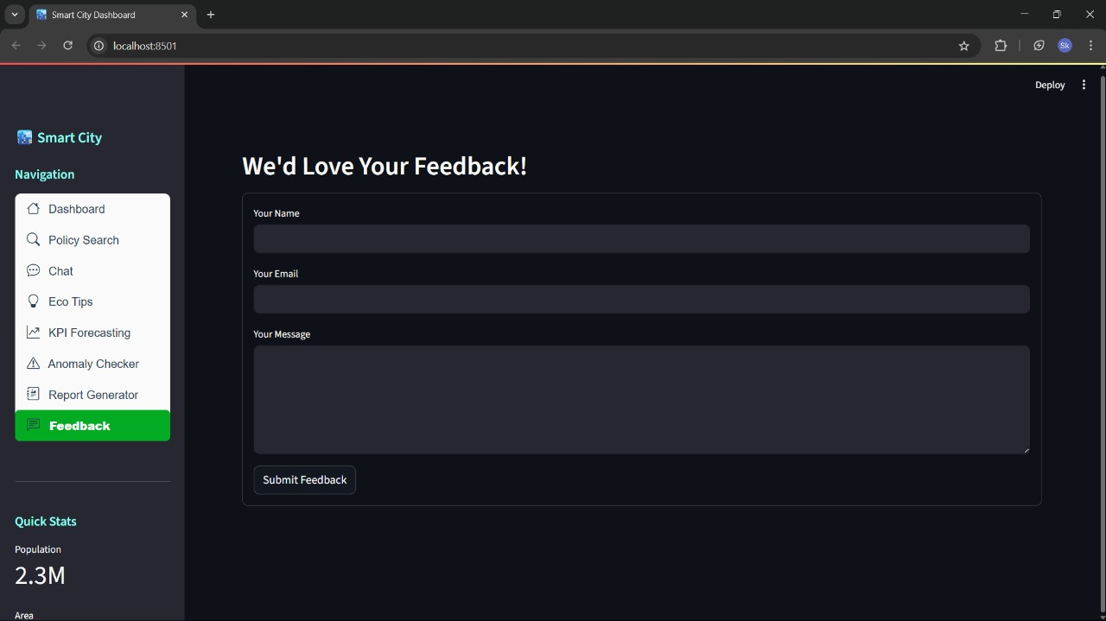
ADVANTAGES & DISADVANTAGES:
Advantages
1. Improves Environmental Awareness
2. Optimizes Resource Usage
3. Encourages Eco-Friendly Behavior
4. Supports Smarter Urban Planning
5. Enhances Quality of Life
6. Promotes Community Engagement
7. Increases Resilience to Climate Change
8. Reduces Operational Costs
9. Boosts Innovation and Green Economy
10. Empowers Decision-Ma
Disadvantages
1. High Implementation Costs
2. Privacy and Data Security Concerns
3. Digital Divide and Accessibility Issues
4. Dependence on Technology
5. Maintenance and System Failures
6. Resistance to Behavioral Change
7. Complex Integration with Existing Infrastructure
8. Risk of Data Misuse or Surveillance
9. Limited Effectiveness Without Public Participation
10.Need for Continuous Updates and Improvements
CONCLUSION
The Sustainable Smart City Assistant represents a transformative step toward greener, more efficient urban living. By integrating AI, IoT, and real-time data, it empowers citizens to make eco-conscious choices and enables city officials to optimize services with precision. This assistant not only bridges the gap between technology and sustainability but also fosters transparency, inclusivity, and resilience in urban ecosystems. As cities continue to grow, such intelligent systems will be essential in shaping a future that is both livable and sustainable Its advantage such as optimizing resource use, raising environmental awareness, and enhancing quality of life make it a powerful tool for modern urban development.However, its effectiveness depends on thoughtful implementation. Challenges like high costs, data privacy concerns, and unequal access must be addressed to ensure inclusive and ethical use. Additionally, the success of such a system relies heavily on public participation and continuous technological updates.
FUTURE SCOPE
- AI-Driven Urban Planning
Predictive models and digital twins will simulate urban growth, optimize zoning, and reduce environmental impact.
- Hyper-Personalized Citizen Services
Assistants will adapt to individual behaviors, offering tailored sustainability tips, transport suggestions, and energy-saving nudges.
- Autonomous Infrastructure Management
Integration with robotics and AI will enable self-healing infrastructure—like automated road repairs or smart waste drones.
- Climate Resilience & Disaster Response
Real-time data and AI will help cities predict, prepare for, and respond to climate events like floods, heatwaves, or wildfires.
- Green Economy Integration
Assistants will connect citizens and businesses to carbon credit systems, green job opportunities, and circular economy platforms.
- Ethical AI & Digital Inclusion
Future systems will prioritize fairness, accessibility, and transparency—ensuring all citizens benefit, regardless of age or ability.
- Cross-City Collaboration
Smart assistants may form networks across cities, sharing anonymized data to benchmark sustainability and co-develop solution

Submitted by:
Kotnani Naga Hutesh
Katta Sai Sri Venkata Trinadha Ganesh
Kasani Vinayak Goud
Kandula Lakshmi

